- \Operation\Basic settings\Tube dimensions
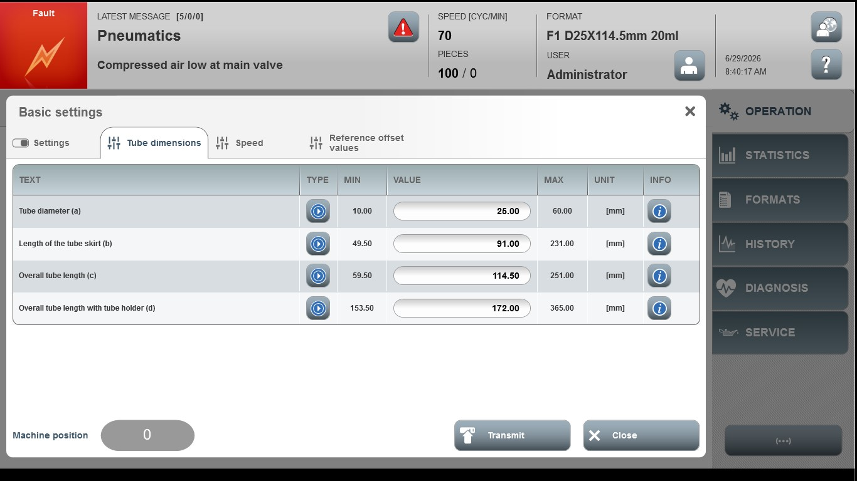
Acceptance criterion | Limits | Pass / Fail: Dev-No. | Date | Initials
Screen matches screenshot | N / A
Tube diameter (a) | 10.0 … 60.00
Length of the tube skirt (b) | 49.50 … 231.00
Over tube length (c) | 59.50 … 251.00
Overall tube length with tube  Holder (d) | 153.50 … 365.00

